=============================== JRTP Real Time Tools ================================

Maven
Maven : Normal ga pom.xml lo manam yedavina dependency ni add chesethe a dependency ki kavalasina internal dependency ni kuda maven by default ga add chesthundi eila cheyatanni
Transitive dipendency Management

Maven lo dependencys anevi first time Central / Remote nuodi download avvi local lo store avuthay next time same dependency kavali ante local nuodi load avuthay or New avithene Central / Remote point avuthay
Central Repo : common repo for JAVA/ Spring Team
Remote Repo ( edi Devops team ready chesthundi) : Our Company already build Jar files dependency only
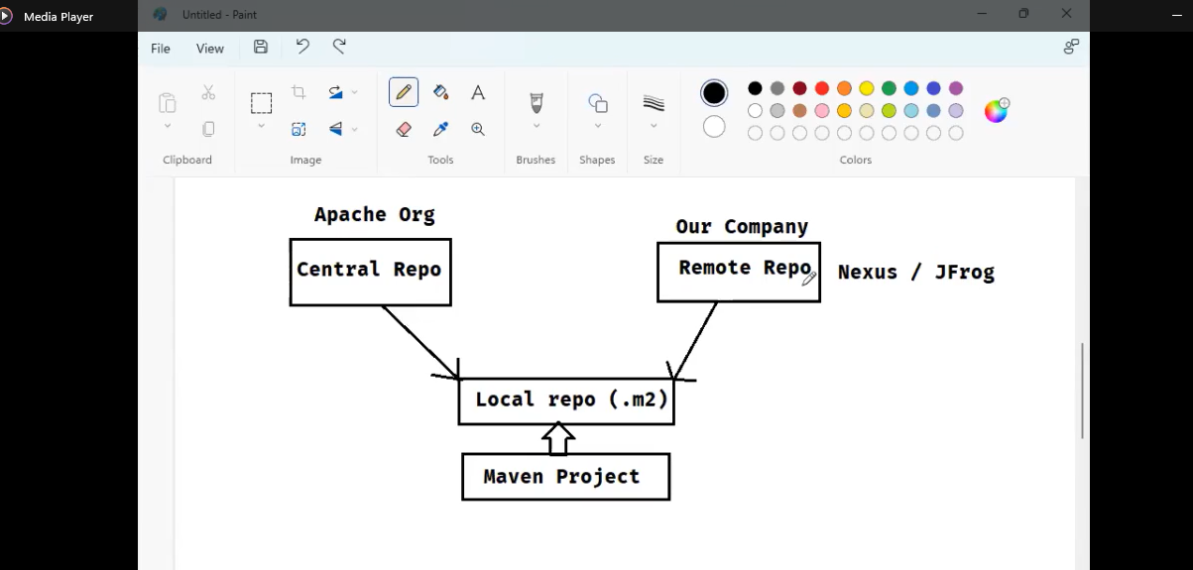

Remote Repo : details and how add Remote Repo configuration in our pom.xml
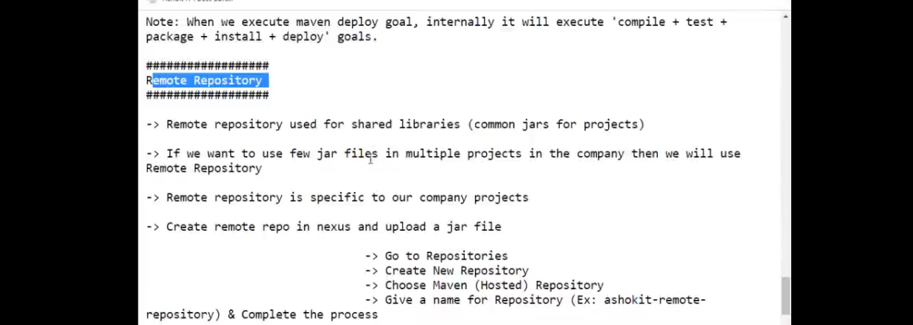

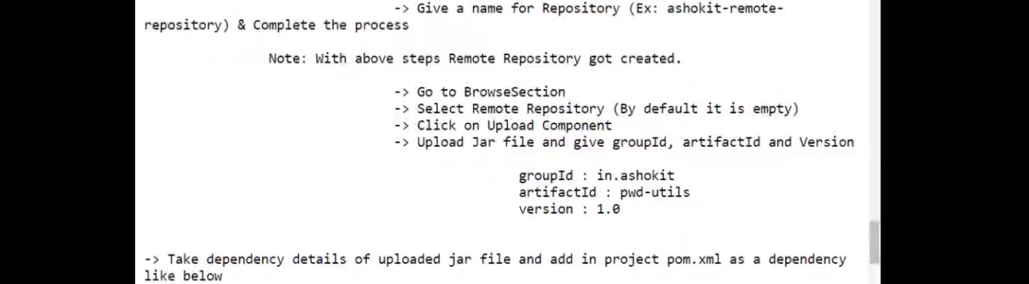

These are the EX: configurations for pom.xml
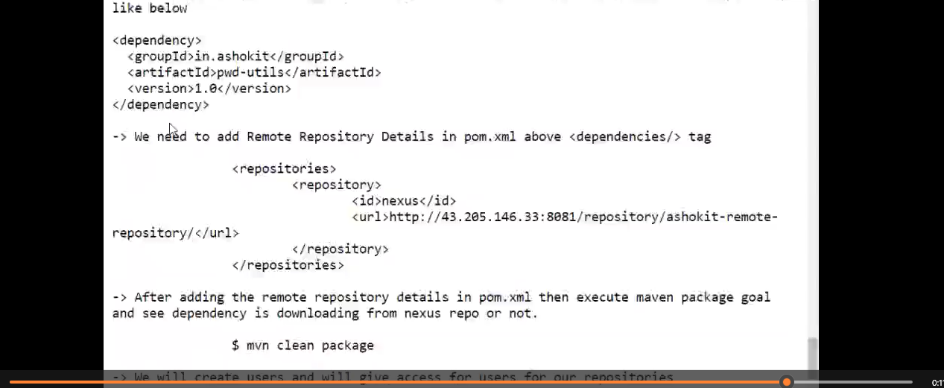

REal time lo company's diniki related credentials eisthe a web site lo login avvi use chesukovatame
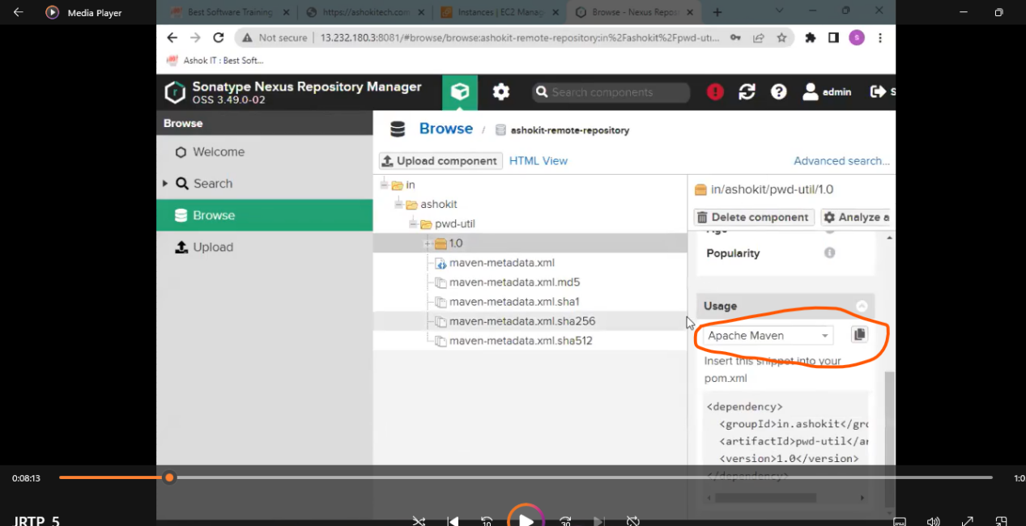

Maven Multi-Module vs Microservices

A Maven multi-module project is a structure where one parent POM contains multiple sub-modules, allowing shared dependencies and common build configuration.

For microservices, we normally do NOT use multi-module projects because each microservice should be:

- independently developed
- independently built
- independently deployed
- independently versioned

Using multi-modules couples services together, which goes against microservice principles.

Multi-module is only useful for:

- shared libraries (common DTOs, utils)
- small projects or POCs
- monorepos with one team
Conclusion: In real microservice architectures, each service should be its own independent project, not a Maven multi-module.

GIT & Git -Hub

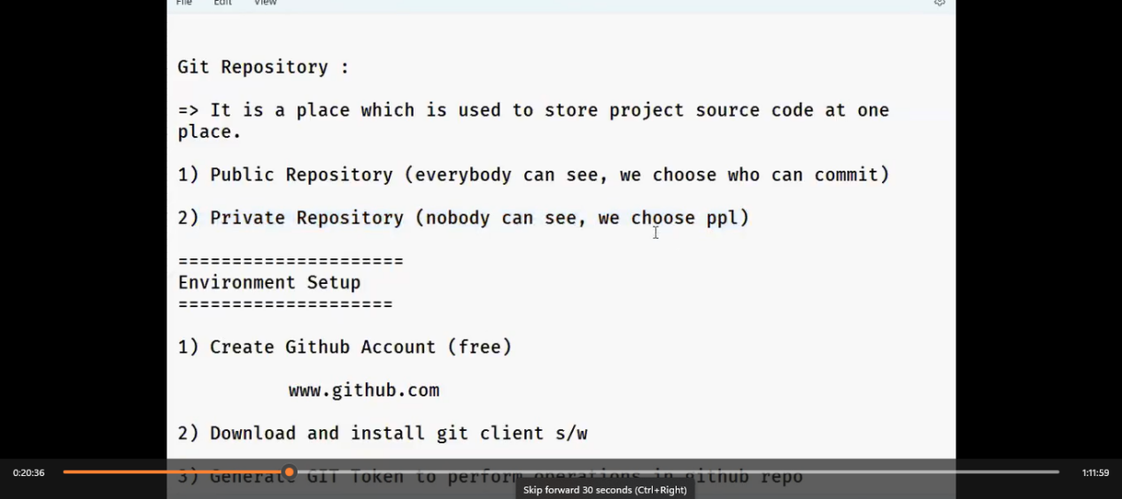

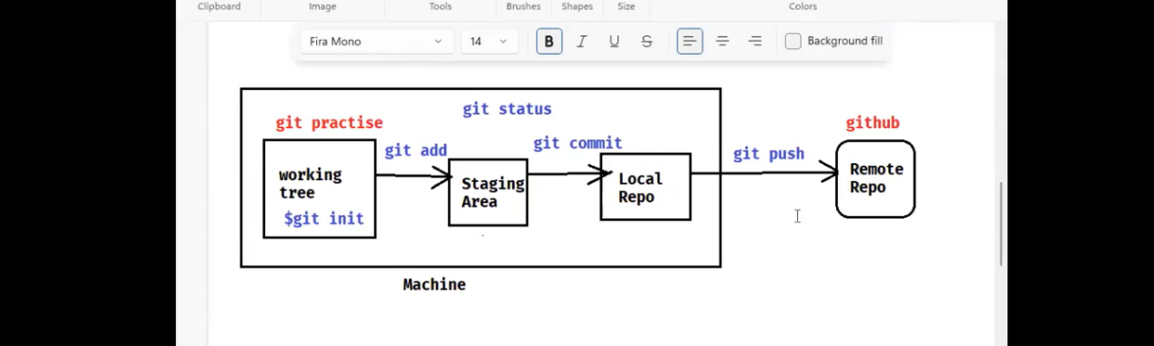

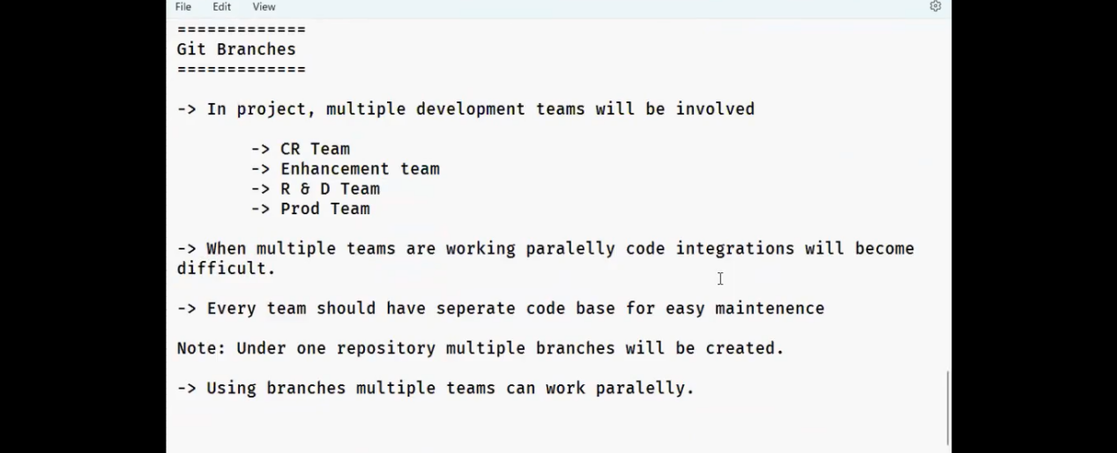

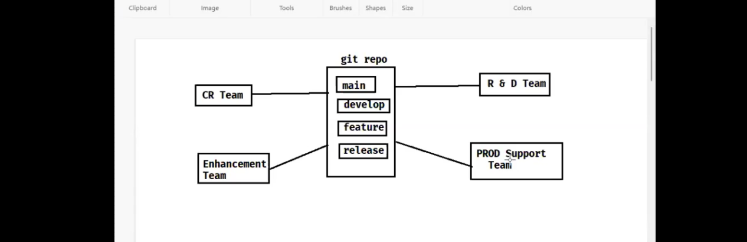
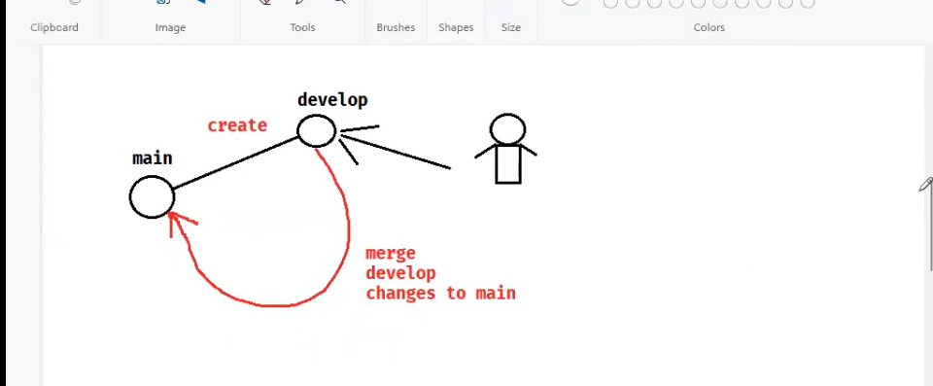
Soem common relatime use cases diffrences
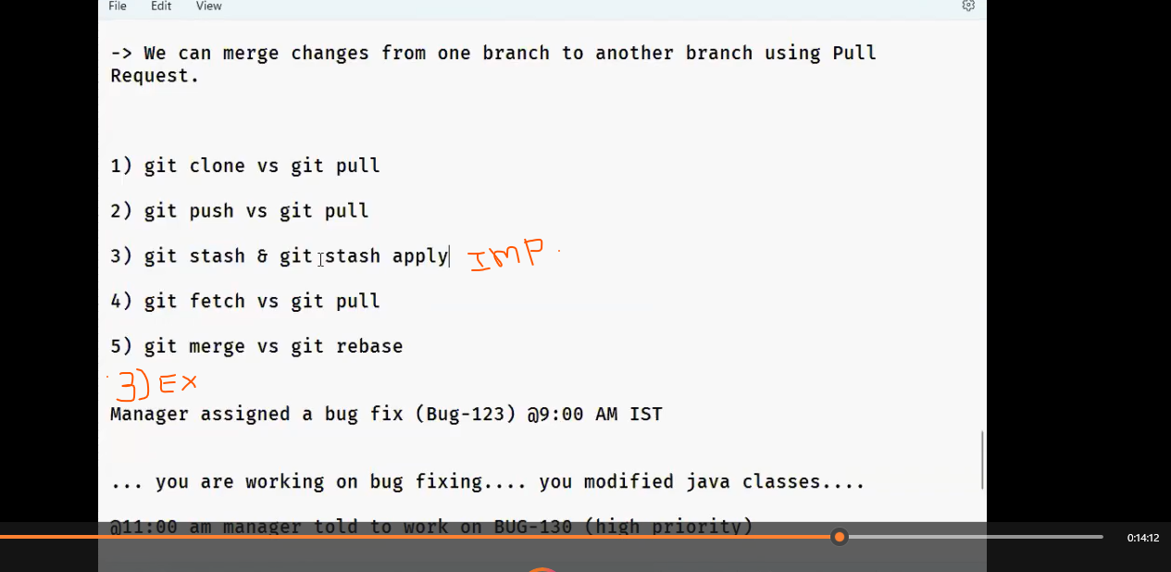

Pull Request : GIT HUB lo raise chestham - -> team lead code review chesaka main brach ki move avuthadi

Merge : edi git bash lo use chesthamu e cmd vadi proper comments tho main branch ki move cheyachu

Rebase : edi git bash lo use chesthamu e cmd vadi proper comments lekunda direct ga main branch ki move cheyachu
So, E mudu kuda code ni main brach ki move cheyatanike use chesthamu … avsaranni batti use chesukovachhu : BUT mostly Pull request ye vadatharu

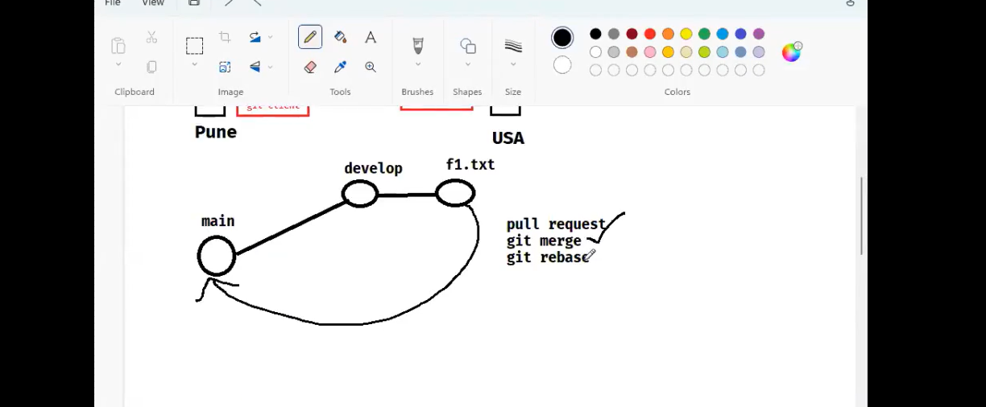

What is git Tagging in GIT HUB ?
Manam rasina code ni deployment ki batch wise ga work avve code ni pampali anukunte edi use avuthundi .. means oka batch lo issues fix chesaka vatini matharame production ki move cheyali anukunnam but work anedi apakunda code rathune vuntam kada ala rasinappudu anni kalisi pothay kanuknda manki yedavarki ok anukunte akkadi daka e tagging vadi verstion chesukoni Next man work ni continue chesukovachhu

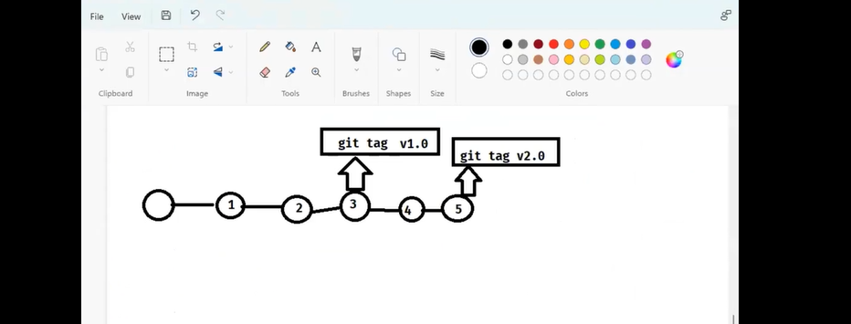
tagging CMD’s :
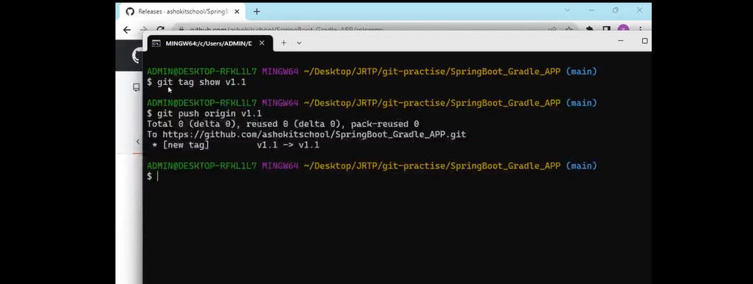

Logging
Logging anedi application ni track cheyataniki use chesthamu : Logging anevi 4 types vadathamu and evi issues ni track cheyatam lo help avuthay

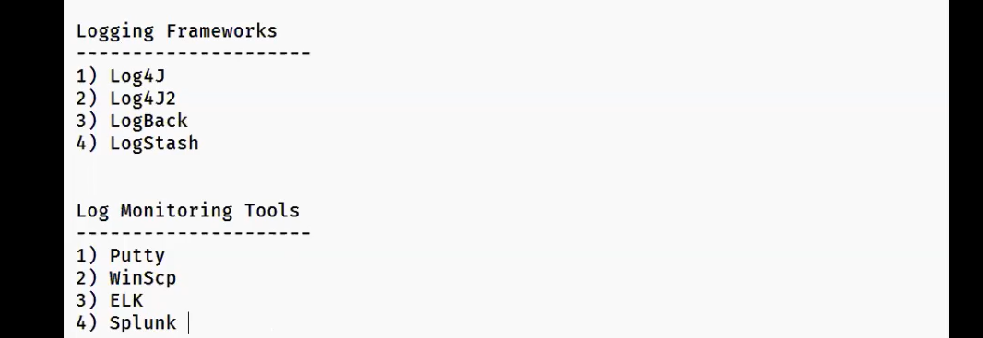

Spring boot lo Spring web app dependency ni add chesthe by default ga SLF4j vasthundi : manaki remain logging kavali ante vati dependency ni add chesukovali

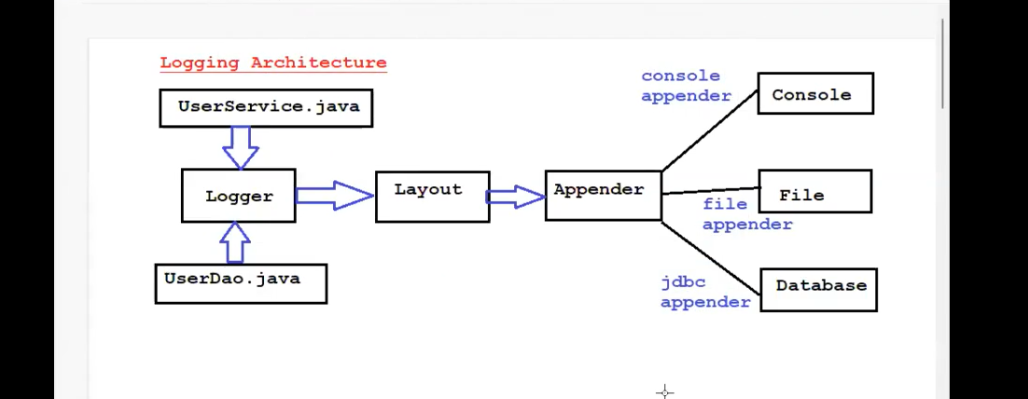

Spring lo by default ga console Appender vasthudi : logs console lo print avuthay if we use SLF4j
Kavali ante file lo kuda print chesukovachhu

Below tag rasthe project lone oka file create avvi andulo print avuthay : kavali ante manaki nachhina location echhi kuda logs ni print chesukovachhu



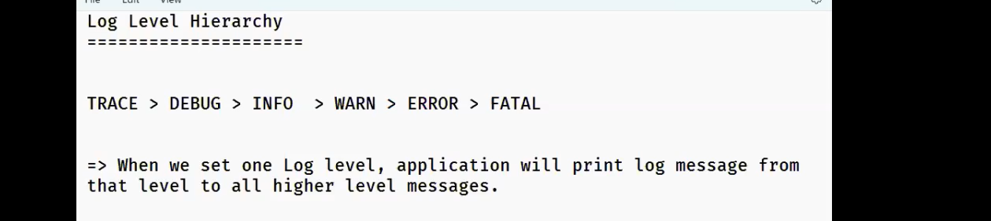
Spring by default log level is INFO : so manam logs ni INFO kanna thakkunva vunna vatini matharame print cheyagalamu
But log level ni application.properties file lo change chesthe manki nachhina log level ni set chesukovachhu

Log rayatam Example :
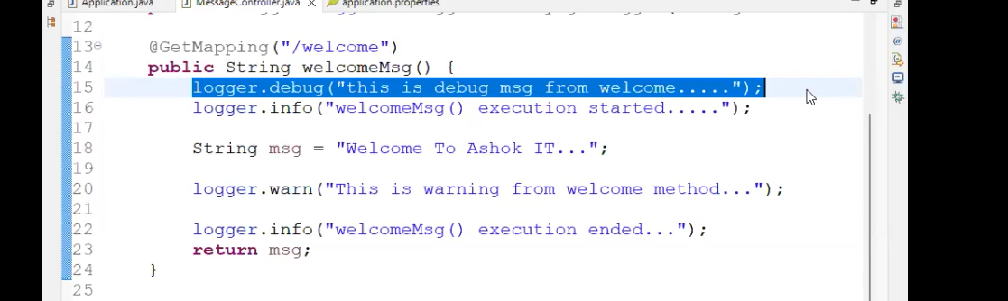

Log level ni set cheyatm
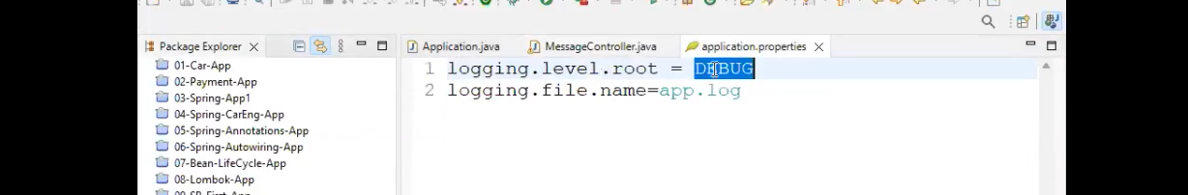

Log level ni entire ki project ki alene layer wise ga kuda set chesukovachu belowis the example

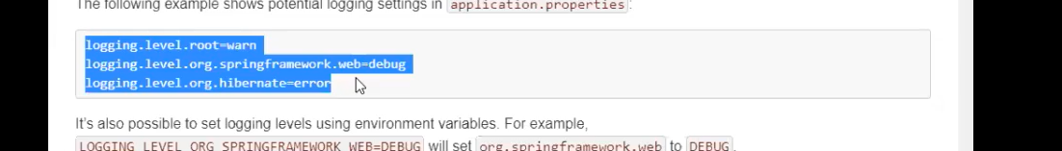

Logger file ni size and time base tho new files ni create cheyachhu
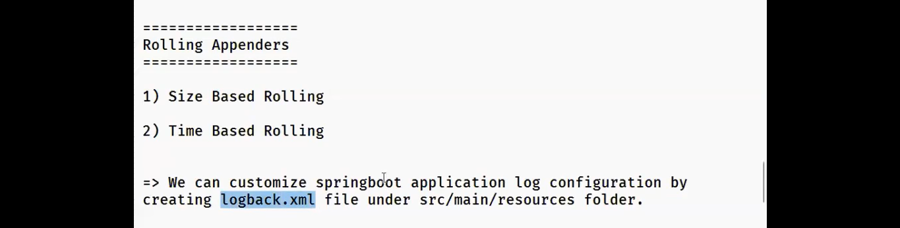

Note : default configuration kakunda manaki nachhina format lo config chesukovali ante logback.xml file ni project lo create cheyalo
EX :
